Dr Harouna KABORE
Doctor of Business Administration (DBA)
Expert in industrial performance and energy efficiency
Business manager
Former Minister of Trade, Industry and Crafts of Burkina (2018-2021)

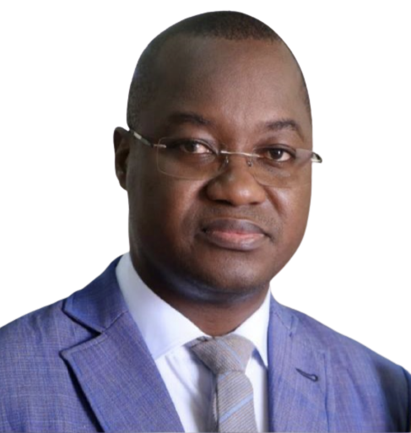
Main areas of expertise :
Formulation of public development policies
Formulation of investment promotion strategies
Formulation of business climate improvement strategies
Optimization of agricultural value chains
Industrial performance and energy efficiency
Lobbying and advocacy

________________________________________________________________________
Specific experiences in promoting investments and improving the business climate for the attractiveness of Burkina Faso
- Management of the formulation and implementation of the investment promotion strategy in Burkina: investments by local actors and foreign direct investments (FDI)
- Management of the creation of the Burkinabè Investment Agency (ABI) in 2019
- Steering the formulation and adoption of the law on the investment code of Burkina in 2019
- Structuring and setting up of a network of activities of economic affairs advisers in diplomatic representations abroad for the promotion of FDI
- Organizers of “invest in Burkina” forums in several foreign countries
- Participation in the structuring of the network of investment promotion agencies in the WAEMU space
- Piloting the formulation of Burkina's business climate improvement strategy in 2021
- Management of the formulation and implementation of "Made In Burkina"
- Management of the formulation of structuring projects for the mobilization of private partners within the framework of PPPs
- Management of the implementation of the Burkina Entry Portal (PEB), reforms of business licenses, the online business creation portal, etc.

August 2022

